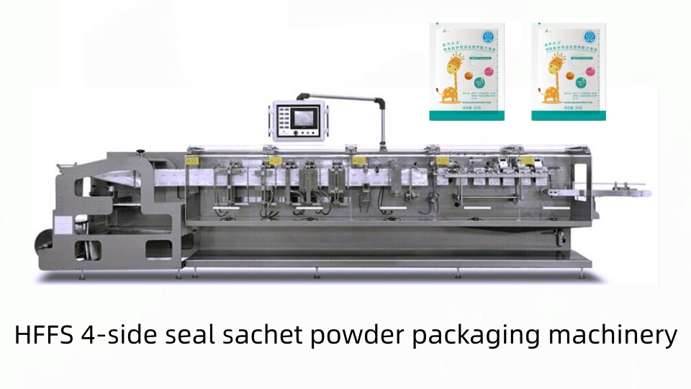
https://www.youtube.com/embed/9kXMj1FiMEA?list=PLQ8oRFWUpA3xlHZhRc4DcJQi8HNDAu07Z

HFFS 4-side seal sachet packaging machinery can package milk powder, seasoning powder, medicine powder, fruit powder, bakery powder, etc. Packaging process is precisely controlled by a PLC, making it easy to operate.

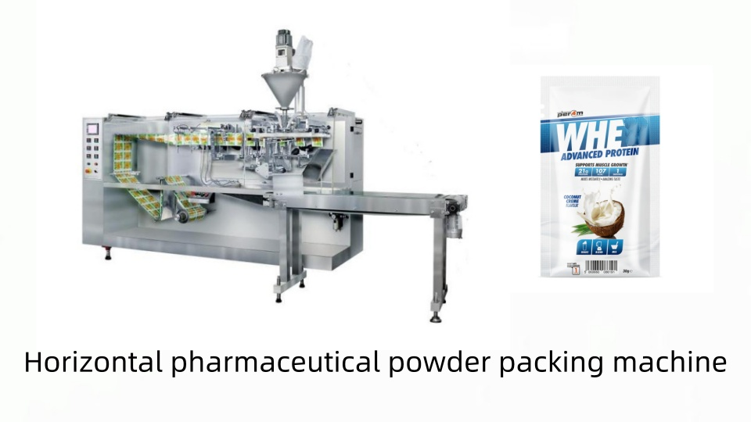
https://www.youtube.com/embed/7areSGo_Jnc?list=PLQ8oRFWUpA3xlHZhRc4DcJQi8HNDAu07Z

Horizontal pharmaceutical powder 3 sides sealed pouch packing machine has been exported to the Chile. Easy-tear openings, rounded corner cutters, date printing devices, etc., can be added according to customer requirements.

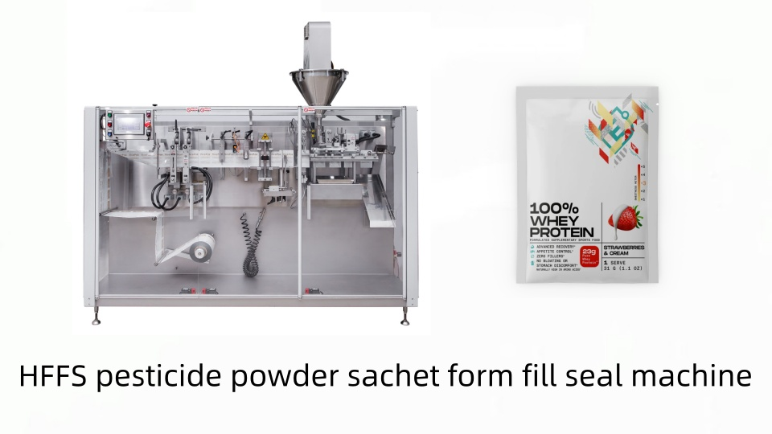
https://www.youtube.com/embed/A4YVoCudHzk?list=PLQ8oRFWUpA3xlHZhRc4DcJQi8HNDAu07Z

HFFS pesticide powder form fill seal machine can produce 3 and 4 sides sealed sachets. his machine was customized to meet the requirements of a US customer. Sachets have excellent sealing properties and are aesthetically pleasing.
HFFS 4-side seal sachet powder packing machine is a fully servo motion : This smart servo-control system allows independent operation between the different stations, offers great reliability and little maintenance. Choose the filling method based on the characteristics of the packaging material: 1. Auger filler for powder products. 2. Volumetric filler for granules. 3. Piston filler for liquids/paste products. 4. Multi-head scale or linear scale for granules or solid products.
HFFS Powder Packaging Machine Operating Procedures: 1.Film Unwind 2.Bottom Hole Punching 3.Bag Forming 4.Film Guide 5.Bottom Seal 6.Vertical Seal l 7.Vertical Seal II 8.Tear Notch 9.Photocell 10.Servo Advance 11.Cutting 12.Pouch Catching 13. Pouch Opening 14.Air Flushing 15.Filling I 16.Filling II 17.Top Seal I 18.Top Seal II 19.Finished Product 20.Outlet

Automatic HFFS FB-180 packaging machines are suitable for industries such as food, medicine, and cosmetics. It is widely used in packing powder product, such as: flour, fruit flavored powder, milk powder, medicine powder, facial mask powder, pearl powder, etc.

FB HFFS powder packing machines can produce various styles of bags: 3-side seal bags, 4-side seal bags, irregularly shaped bags, perforated bags, and other flat bags. Different devices can be added depending on the type of bag, such as easy-tear openings, shape cutters, perforation devices, and zippers.

Type  型号 | Width of pouch  制袋宽度 | Length of pouch  制袋长宽 | Speed of machine  机械速度 | Power  功率 | Dimension of machine  机器尺寸 | Weight of machine  机器重量
FB-160 | 70-160mm | 70-190mm | 40-80 ppm | 4.5kw | 3200*970*1500mm | 900 kgs
FB-180 | 70-180mm | 70-225mm | 40-120 ppm | 5kw | 3500*970*1500mm | 1400 kgs
FB-240 | 120-240mm | 120-320mm | 40-120 ppm | 6.5kw | 4600*1120*1500mm | 2000 kgs

